Case 4-Eur-Roman-Rhytyon-Sheep’s Head-Terra Cotta-250-350- CE

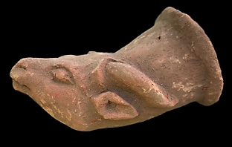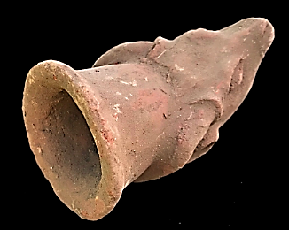

**Case no.:**

**Accession Number:**

**Formal Label:**

**Display Description:**

**LC Classification:**

**Date or Time Horizon:**

**Geographical Area:**

**Map:**

**GPS coordinates:**

**Cultural Affiliation:**

**Media:**

**Dimensions:**

**Weight:**

**Condition:**

**Provenance:**

**Discussion:**

**References:**

|  |  |
| --- | --- |
| RDER DATE  May 19, 2018 | ORDER TOTAL  US $49.46  + US $13.37  shipping  **Order ANCIENT ROMAN TERRACOTTA RHYTON DRINKING VESSEL 250-350 AD. (2)**[Return this item](https://www.ebay.com/rtn/Return/ReturnViewSelectedItem?transactionId=0&itemId=332652159641&_trksid=p2057872.m2749.l3185)[Leave feedback](http://feedback.ebay.com/ws/eBayISAPI.dll?LeaveFeedbackShow&useridto=handsofhistory&transactID=0&item=332652159641&_trksid=p2057872.m2749.l2665)  [More actions](https://www.ebay.com/myb/PurchaseHistory) |

1 item sold by [handsofhistory](http://www.ebay.com/usr/handsofhistory?_trksid=p2057872.m2749.l2754" \o "handsofhistory user ID, click for member’s profile)

|  |
| --- |
| [ANCIENT ROMAN TERRACOTTA RHYTON DRINKING VESSEL 250-350 AD. (2)](https://www.ebay.com/itm/ANCIENT-ROMAN-TERRACOTTA-RHYTON-DRINKING-VESSEL-250-350-AD-2/332652159641?ssPageName=STRK:MEBIDX:IT&_trksid=p2057872.m2749.l2648)  [ANCIENT ROMAN TERRACOTTA RHYTON DRINKING VESSEL 250-350 AD. (2)](https://www.ebay.com/itm/ANCIENT-ROMAN-TERRACOTTA-RHYTON-DRINKING-VESSEL-250-350-AD-2/332652159641?ssPageName=STRK%3AMEBIDX%3AIT&_trksid=p2057872.m2749.l2649)  ( 332652159641 )  Delivered on **May 25, 2018**  Tracking number: [**Tracking numberLB847792746GB**](javascript:;)  This item has been shipped. |